Thomas Satterly

AAE 550, Final Project Report

Geometry Optimization of a Scramjet Combustor

**Objective**

This project aims to optimize the geometry of a rectangular profile scramjet combustor for maximum thrust by varying the contour of one of the combustor walls. For simplification purposes, it is assumed that the nozzle perfectly and isentropically expands the resultant flow, producing the maximum thrust possible for a given combustor design.

For this project, it is assumed the scramjet is operating at a 20 km altitude, cruising at Mach 5, and ingesting 100 kg/s of air with a 0.3 pressure recovery factor and a 1/3 Mach recovery factor through the inlet and isolator system. The combustor has a rectangular cross section with a 5:1 aspect ratio and is 3 meters long. A single wall is split into 20 equal segments whose angles can be individually altered to create a contour. Hydrogen fuel is used at an equivalency ratio of 0.9. Further details on the fuel injection regime can be found in the appendix.

The maximum jet thrust produced by the combustor is a function of the exit conditions of the combustor, which themselves are a function of the combustor properties. For easier representation, the thrust equation is reduced to the following form:

T

In this representation, is the angle of the *nth* wall section that together compose the design variable matrix , and is the collection of parameters that defines the initial starting conditions. Transforming the problem from a maximization to minimization problem, the objective becomes:

**Constraints**

Constraints were placed on the model to keep the solution feasible and practical. First, and consecutive wall segments along the contour must be angles within 5 degrees of each other to prevent large changes in combustor geometry that could cause flow separation or strong shocks in the flow. Additionally, the wall angles were bounded to greater than or equal to 0, but less than or equal to 25 degrees. Second, at any point in the flow, the Mach number must be greater than or equal to 1.05. Perturbations in the upstream flow could cause the Mach number to drop, and if Mach 1 is reached, the flow chokes and risks unstarting the inlet system, causing a dramatic loss of thrust and, most likely, a failed mission. The exit Mach from the combustor must be at least 1.15 so that afterburning remains feasible without running a great risk of thermally choking the flow. Finally, the maximum temperature in the combustor is limited to 3000 K in order to keep heat loads manageable.

The nonlinear constraint functions, derived from the physical constraints above are as follows:

As before, is the angle of a wall section and is the design variable of interest. is the Mach number at the *mth* integration step, and likewise, is the static temperature at the *mth* integration step. The total number of nonlinear constraint equations depends upon the total number of wall sections (whose angle can be varied) and the total number of integration steps along the combustor. In a model with 20 wall sections and an integration step of 1 cm produces 679 constraint equations. The lower and upper bounds for wall angles are linear constraints, and as such, are simple and not represented in the above equations.

**Scramjet Combustor Model**

The scramjet combustor model is given by Shapiro as a 1-D analysis, of which the main relations are given below.

Standard isentropic relations for compressible flows as well as the continuity equations combine with those provided by Shapiro to create a unified model. The changing values of the specific heat (*cp*) and the ratio of specific heats () are calculated using NASA’s Chemical Equilibrium with Applications (CEA) program, which is a chemical property solver developed for determining the thermodynamic properties and physical state of complex mixtures of reactants. The effects of cooling at the wall and wall friction were ignored for simplification purposes. To determine combustor properties, the above equations are numerically integrated while using CEA to update thermodynamic properties at each integration step.

The major functional portions of code are provided in the appendix. The full code base, which is too large to reasonably attach in PDF form, is available in full upon request.

**Methodology**

The Sequential Quadratic Programing (SQP) optimization algorithm was used for a multitude of reasons. With the combustor taking significant computation time to solve, the fast and relatively efficient nature of SQP will make the problem more feasible in the allotted time. There is a significant chance the optimization procedure will venture into unfeasible territory easily, which SQP can handle. Additionally, the non-linear nature of the flow field constraints will be better represented by SQP than other strictly linear methods. There was a risk of stepping outside of the continuous domain of the objective function, which occurs when the Mach number in the combustor drops below 1, but the constraints put in place due to the physical ramifications of this scenario prevent such discontinuities from occurring. Matlab’s “fmincon” function with the SQP algorithm was used in practice.

The scramjet combustor model was also developed in Matlab. Calculating the gradients of the objective and constraint functions was not possible to do analytically, and extremely time consuming when done numerically. To make gradient calculations more feasible, a significant amount of effort was put into making the model more computationally efficient as well as parallelizing numeric gradient calculations. All gradients were calculated using the forward difference method in order to minimize the number of objective function calls. The model was also developed to have flexible integration fidelity so that, should optimization become intractable within the allotted project time, a low-fidelity solution could be found.

**Results**

A combustor was optimized using a 1 cm integration step resolution and 20 variable angle wall segments, which produces a thrust of 332.982 kN. The SQP algorithm produced an optimal solution (local minimum that satisfies constraints) after 120 iterations and 2856 function calls. The starting point (x0) for optimization was chosen as a linear progression of wall angles from 15 degrees at the start to 20 degrees at the end, which was chosen to satisfy all constraints. A side view of the optimized geometry for the combustor is shown below.

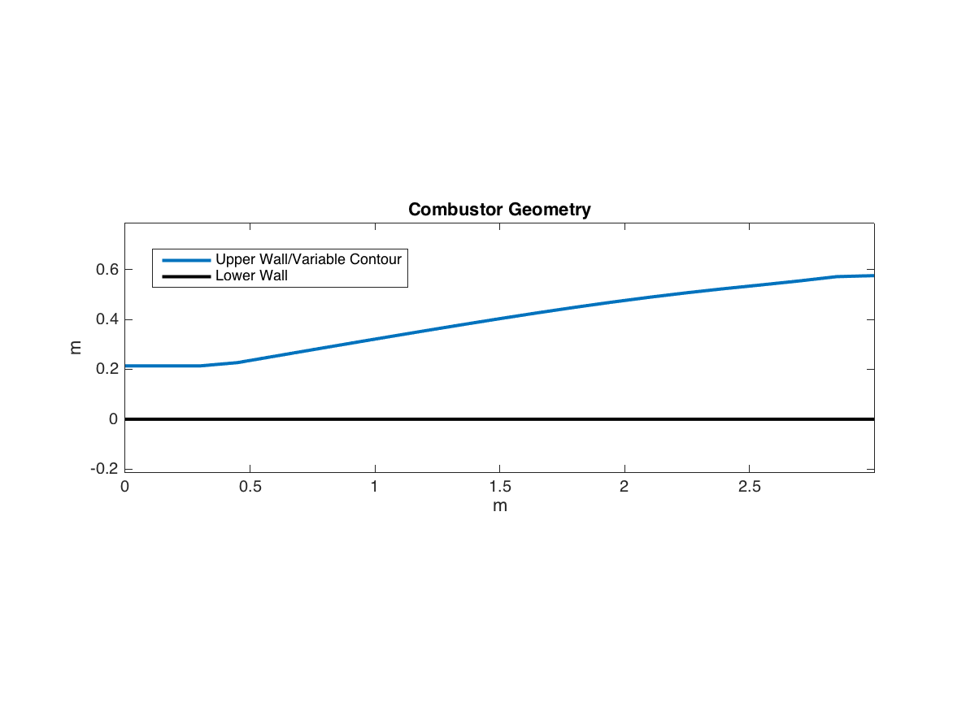

For most of the length of the combustor, the minimum Mach of 1.05 was the active constraint. At the start of the combustor, the minimum wall angle bound of 0 degrees was active, and towards the end of the combustor, the maximum static temperature constraint became active. Neither the minimum exit Mach, upper bound on wall angles, or maximum sequential angle difference were active at any point, and no constraints were violated. The figures below highlight the active constraint sections along the combustor.

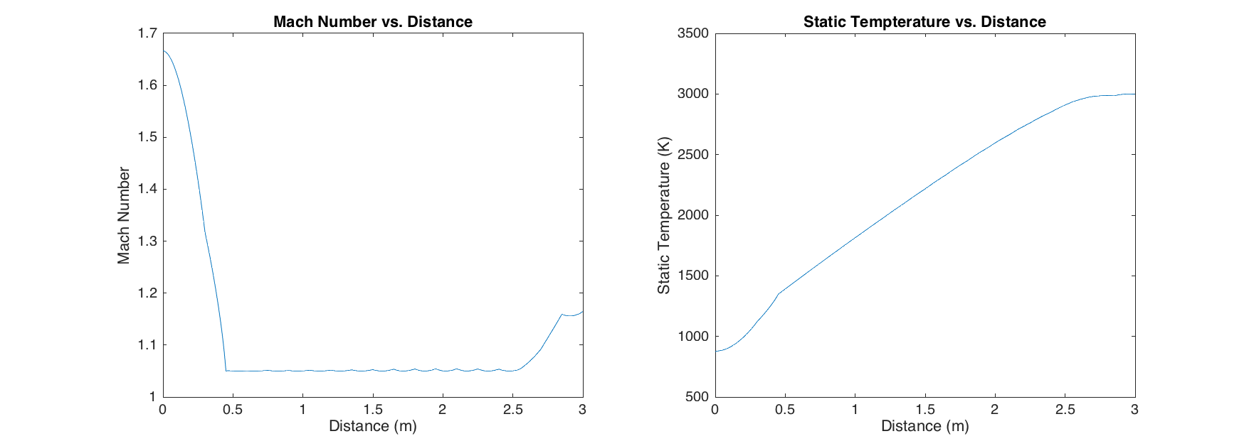

Maximum Temperature Active

Minimum Mach Active

Two more lower fidelity optimizations with a 10 cm integration step size were performed with a reduced maximum temperature of 2700 K and with difference starting points to test if the solution space was multimodal. The first optimization used the same starting point as before, while the second used the starting point of 20 degree angles for all wall sections. It was found that each optimization provided significantly different results, suggesting that the objective function may be multimodal. A table summarizing the differences is shown below.

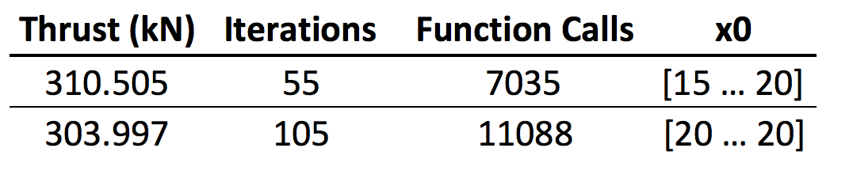

Although the thrust for each design is within 2.6% of each other, the geometry is much more evidently different. An overlaid comparison of the geometry is shown below.

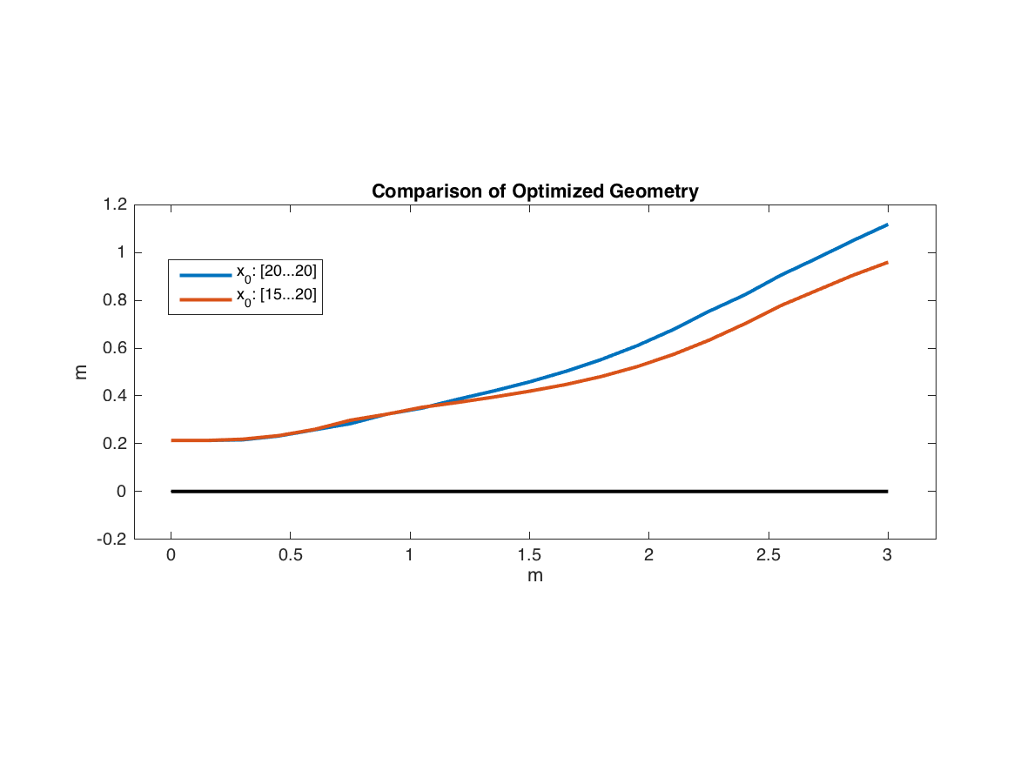

This result is not conclusive that the same behavior would occur on the higher fidelity model. As the integration step size increases, flow property calculations become inaccurate, and a 10 cm step size was chosen for this comparison solely for the purpose of time constraints. A similar analysis using a 1 cm integration step size as before would have taken two days.

**Final Remarks**

The approach outlined and executed in the project has shown that the optimization of a scramjet combustor is possible using 1-D analysis and non-constant flow properties, but the most significant result is realizing the amount of processing power needed to perform such optimizations. A single optimization using a 1 cm integration step took 23 hours to complete on a high-performance consumer machine whilst using four logical compute nodes to run parallel code. A bulk of this time was devoted to computing the numerical gradients, as analytic gradients were not possible for the complex flow model used. If a fully realized optimization were desired, including multiple starting points, and higher resolution integration, the time required would rise to the point where dedicated and large compute clusters are required.

The issue of compute time also highlights the importance of optimization algorithm selection. For example, a lower fidelity model was shown to be multimodal, suggesting that a global search method might be more effective than a multi-start SQP optimization. However, global search methods tend to take more objective function calls than a direct approach, which could once again push the compute time required into intractable territory.

Lastly, the effect of model resolution on the number function calls required to find a solution should be noted. On the initial high-fidelity model, optimization took 2856 function calls. By comparison, each of the lower fidelity models took significantly more function calls, at least 7035. Although this was not investigated further in the project, it seems worth mentioning that a minimum optimum fidelity might need to be considered in similar types of problems so that the gradients of the model represent the true gradients accurately enough for efficient optimization.

Works Cited

Shapiro, A. H. (1953). *The Dynamics and Thermodynamics of Compressible Fluid Flow*. New York.

Chemical Equilibrium with Applications. (n.d.). Retrieved November 27, 2017, from https://www.grc.nasa.gov/www/CEAWeb/ceaHome.htm

Appendix

The fuel injection regime is defined as follows, in kg/s:

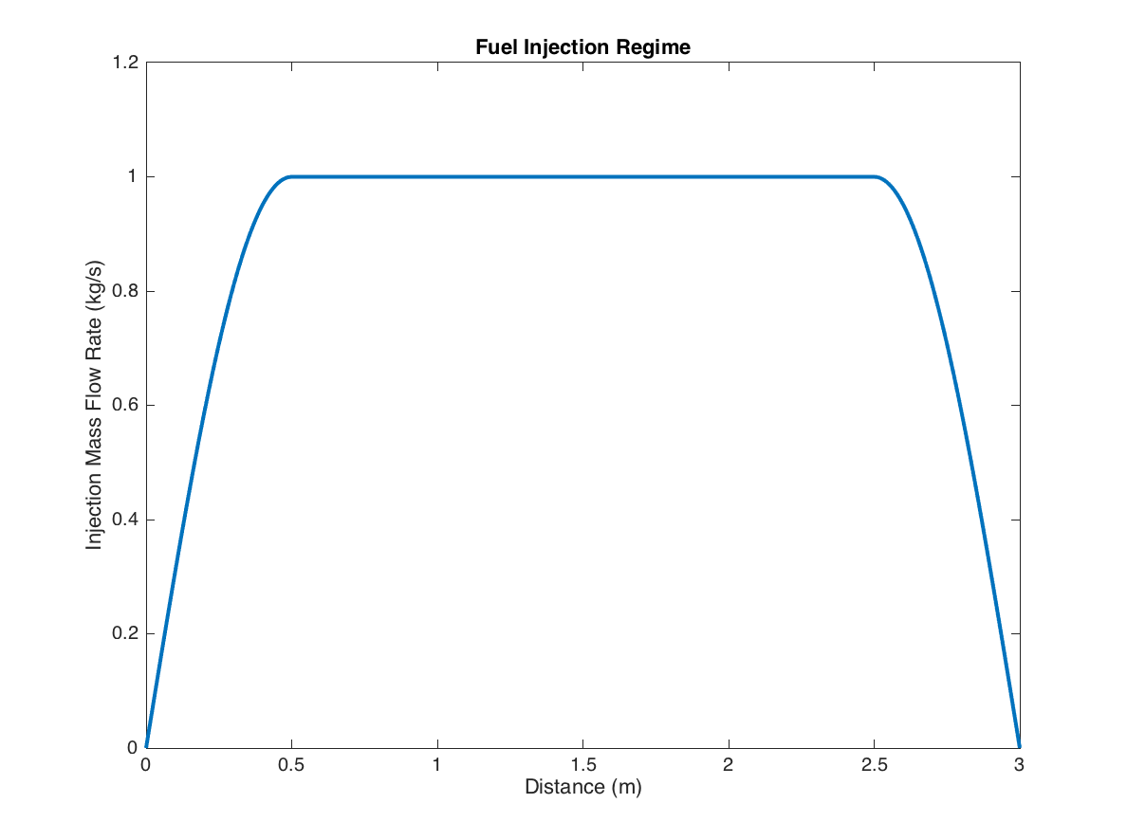

The Shapiro 1-D compressible fluid flow equations used in this project are listed below:

: Local Mach number

: Local Ratio of specific heats

: Distance along the combustor

: Local combustor cross sectional area

: Local total temperature

: Local mass flow rate

: Local specific heat at constant pressure